TASK 13:
class Solution {
public ListNode mergeTwoLists(ListNode list1, ListNode list2) {
ListNode dummy = new ListNode();
ListNode current = dummy;
while (list1 != null && list2 != null) {
if (list1.val <= list2.val) {
current.next = list1;
list1 = list1.next;
} else {
current.next = list2;
list2 = list2.next;
}
current = current.next;
}
current.next = (list1 != null) ? list1 : list2;
return dummy.next;
}
}

Case 1:

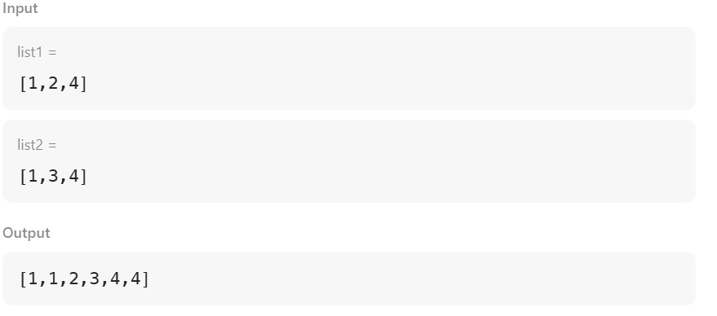

Case 2:
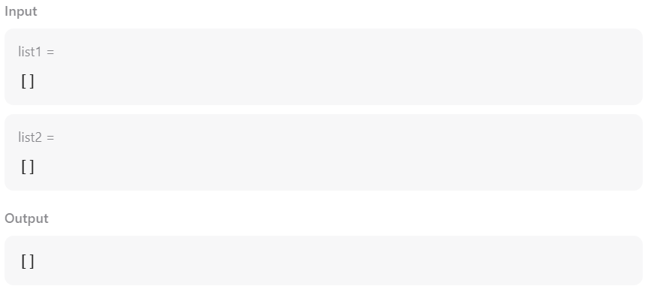

Case 3:
